Impact of Social Media on Mental Health using Machine Learning

**Mrs. Mannat Doultani$, Aryan Manghi#, Prasad Chaudhari#, Devyaansh Razdan#**

$: Assistant Professor, Computer Engineering Department , Vivekanand Education Society’s Institute of Technology, Mumbai

#: Student in Computer Engg. Vivekanand Education Society’s Institute of Technology, Mumbai

# Abstract:

Social media is a major source of information as well as it profoundly affects a person’s personal life. While overuse might lead to more anxiety or mental health issues, less frequent use could foster a feeling of community or social support. Examining social media and mental health survey datasets through the lens of machine learning (ML), the project "Impact of Social Media on Mental Health using ML" tries to explore a phenomenon of social media use and its consequences to mental wellness. By means of trend and relationship detection, the project seeks to grasp what particular social media behaviors: do with a person's wellbeing. Developing an intelligent chatbot that provides tailored recommendations on a user's mental health is a key component of the project. The machine learning-based chatbot will provide contextual advice by analyzing user data and mood markers.

**Keywords:**

**Social media, Mental Health, Machine Learning, Personalized recommendations.**

# Introduction:

Both for adults and children and youths, social media spaces are beneficial in many ways, while often posing serious challenges to their mental wellbeing [1]. In younger children, the growing tide of depression, anxiety and sociability withdrawal is believed to come from the constant demand to project a perfect online self, curated content and media, and the addictiveness of the social media itself. This project titled “The Digital Mindscape: Leveraging Machine Learning to Understand The article "Social Media's Effects on Child Mental Health" aims to clarify this issue.

We aim to better define the negative effects of social media on children's and adolescents' mental health as well as the apparent positive correlations [2]. In order to identify the main contributing factors to social media mental health disorders, we will measure the length of time children spend online, the type of content they consume, and how they react to it.

In addition to identifying the mental health risks associated with excessive use of social media, this project aims to develop workable solutions to these issues [7]. We hope to develop tailored suggestions that help kids and adopt better online practices by examining each user's unique social media usage patterns. We intend to provide customized guidance that can assist families in better understanding how social media affects mental health by utilizing cutting-edge technologies like machine learning.

The knowledge gathered will be used as the basis for wellness initiatives and educational initiatives that stress the value of balancing digital platform use. We hope to develop a framework that tackles the current problems and promotes a healthy digital environment for coming generations by combining data-driven research with community-based initiatives [18].

This project's main goal is to equip adults and kids with the information and tools they need to use social media responsibly. We aim to encourage healthier behaviors and lessen the rising concerns about mental health issues brought on by excessive or unhealthy social media use by raising awareness and offering workable solutions [13]. We can create a digital environment that fosters well-being for all people by working together.

**Literature review:**

1. Connections between children’s well-being and screen time:

In order to assess the effects of screen time on well-being metrics such as self-worth, and emotional well-being, Jean Twenge carefully examines the data collected from a sample of the population in their report [6]. The important conclusion is that extended screen time is associated with worse psychological health, especially when it comes to social satisfaction and emotional well-being.

1. Deep learning based social media depression detection:

This study shows how well deep learning works to identify depression in social media posts [10]. The study demonstrates BERT's superior performance in detecting depression from user-generated text by contrasting transformer-based models with conventional machine learning models.

1. The effects of blue light on young adults’ and adolescents’ sleep, productivity and general well-being:

The effects of blue light exposure (from screens and gadgets) on young adults' sleep patterns, cognitive abilities, and general well-being are examined in this systematic review [17]. It summarizes research on the effects of blue light on circadian cycles and mental health.

4. Sentiment analysis of social media data for identifying depression using AI:

This review discusses how sentiment analysis and AI techniques can be used to detect depression in social media posts. The authors evaluate various AI algorithms, for analyzing user sentiment and emotions in text data [18]. Sentiment analysis using AI offers promising results in detecting depression from social media data, enabling the early identification of mental health issues.

5. The effect of social media within adolescents and young adults:

This review concentrates on the effect of social media on the health of the youth as well as teenagers. It explains that social media use can exacerbate negative feelings because of excessive use [17]. There are mental health problems such as sadness, anxiety, and isolation which have a clear association with social media use among the youth and adolescents.

6. Mental Health inequalities and contributing factors among Indian youth:

The study investigates mental health disparities among Indian youth, focusing on the impact of external validation through social. Social media significantly influences mental health outcomes for Indian youth [1,9], with external validation playing a crucial role. 7. Investigating the link between social media,

mental health and young people: A case study

This research explores the relationship between social media usage and mental health issues among young individuals [12]. The analysis identifies important factors that contribute to social media-related mental health issues. Results point to a growing focus on comprehending how social media affects young people's wellbeing.

8. Early detection of mental health issues in children using ML

In this study, ML models are being used to detect mental health issues in children early on [3,7]. Finding patterns in social media use and other pertinent variables linked to early signs of mental health issues is the main goal of the study.

9. Screen Time and brain development in Preschoolers:

The effect of screen-based media on preschool-aged children's white matter structure is investigated in this study [1]. The study investigates the connection between media consumption and brain development using neuroimaging methods. The findings show that increased screen time is linked to decreased white matter integrity, which may have an impact on young children's literacy development.

**Methodology:**

Machine learning processes begin with social media data analysis to detect behavioral patterns and risk features for mental disorders such as depression, anxiety, and addiction [5,14]. The information will be sourced from social media surveys and questionnaires, along with the level of screen time users spend watching media, as well as the consumption and activity frequency. This diverse data set will help to clarify the relation between different social media activities and mental health issues. Data cleaning, which is part of the preprocessing step, consists of addressing missing values and duplicates, in addition to feature engineering where meaningful attributes like average daily screen time and exposure frequency to different types of content (negative, news, and comparison-based) are constructed. Following data preparation, it will undergo annotation to train the ML models appropriately.

The project scope has both a supervised and unsupervised aspect: a randomized forest along with a support vector machine will carry out classification and prediction of mental health conditions in correspondence with social media activity [15]. K-means algorithms will detect other clusters of users characterized with similar behaviors. Also, some correlations will be analyzed, and sentiment analysis is going to be included to reveal nuances.

Formula for evaluation metrics:

1. Precision = TP/(TP + FP)
2. Accuracy = (TP + TN)/(TP+TN+FP+FN)
3. Recall = TP/(TP + FN)

where,

TP = True Positives

FP = False Positives

TN = True Negatives

FN = False Negatives

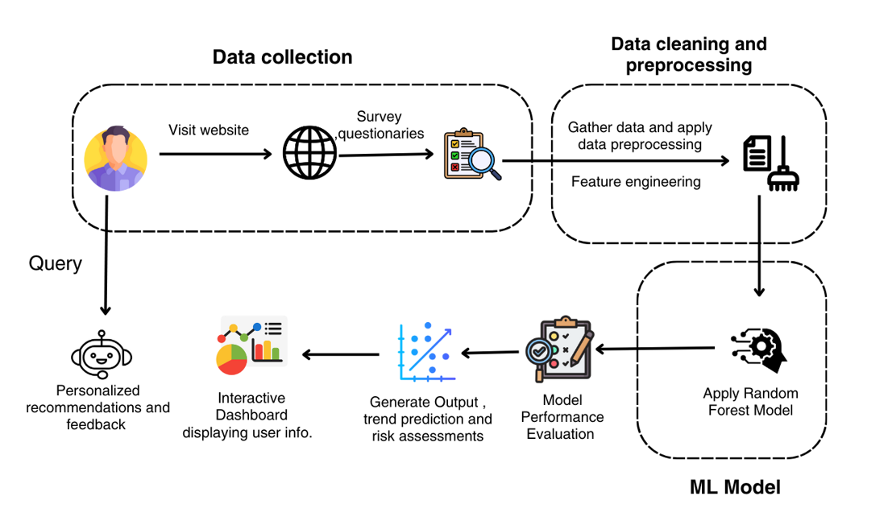

**Fig.1 Modular Diagram**

In the provided diagram, the system is broken down into the following modules:

1. Data collection: Gather data from various sources such as website & surveys
2. Data cleaning & processing: To clean & prepare data for analysis.
3. Feature Engineering: Create new features from existing data.
4. ML Model: Random Forest is applied.
5. Model performance evaluation: To access accuracy & effectiveness.
6. Generate output: Final result such as trend prediction, risk assessment
7. Interactive dashboard: Explore data & insights.

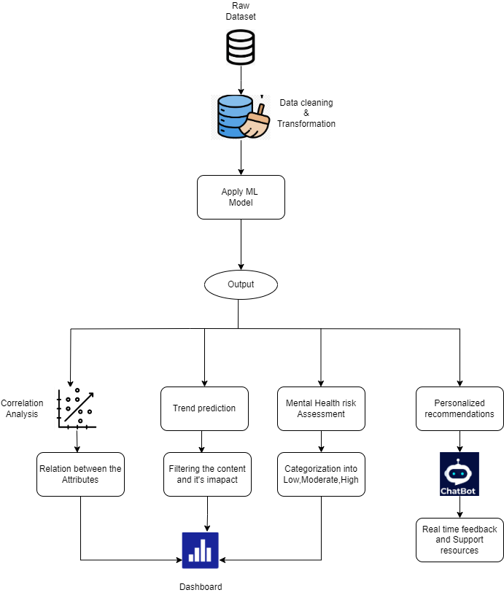

**Fig.2 Block Diagram**

This research adopts a methodical strategy to examine the influence of social media on children's mental health by utilizing machine learning methods [15]. The approach adheres to an organized sequence, commencing with the gathering of data, its preprocessing, and the application of a machine learning model to derive insights. The objective is to evaluate mental health risks and offer tailored recommendations.

The research involves multiple analytical processes, including correlation analysis, trend prediction [11], and personalized recommendations through a chatbot. A Random Forest model is applied to predict depression levels, categorizing users into Low, Moderate, or High risk.

1. Data Collection:

The dataset is collected from surveys, interviews, or existing mental health research databases [9] . It includes 26 key attributes, such as age, gender, social media usage, screen time, etc.

2. Data Cleaning & Transformation: To maintain high data quality, missing values are addressed through imputation methods, such as using the mean, for numerical data, while categorical data is filled in with the most common category [14].

3.Machine Learning Model Application: The Random Forest model is chosen because of its excellent accuracy in classification tasks [2,4], making it suitable for predicting mental health risk levels. To enhance its performance, hyperparameter tuning is carried out.

4. Model Output & Analysis: The study includes correlation analysis to identify relationships between attributes like excessive screen time and anxiety. Trend prediction analyzes content impact on mental health and tracks behavioral changes. Mental health risk assessment categorizes individuals into Low, Moderate [8,10], or High-risk levels for early detection. A chatbot provides personalized recommendations, suggesting reduced screen time.

# Result & its interpretation:

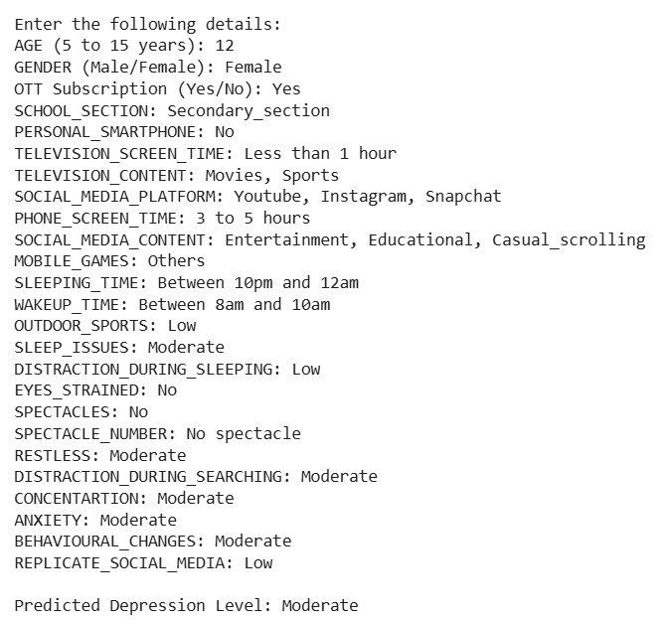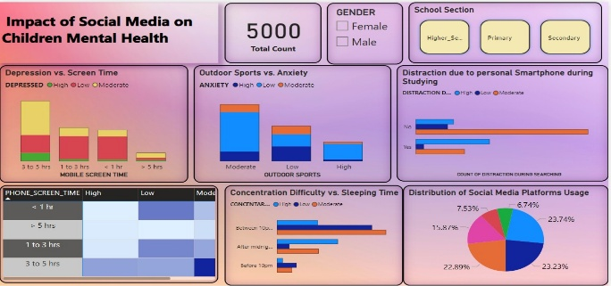

**Fig. 3 Dashboard**

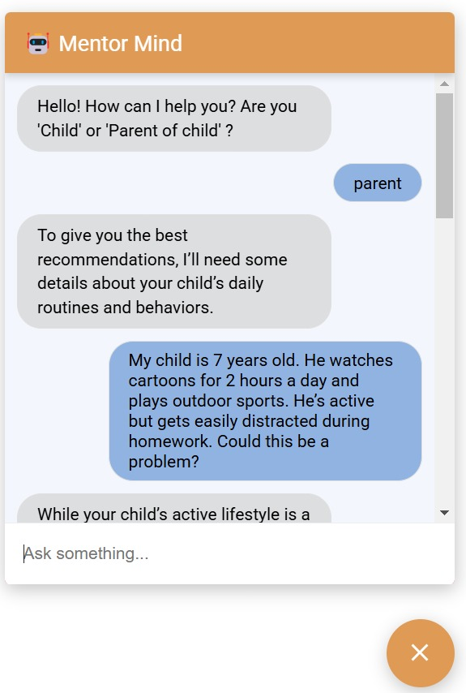

**Fig. 4 Chatbot Fig. 6 Apply ML model on input features**

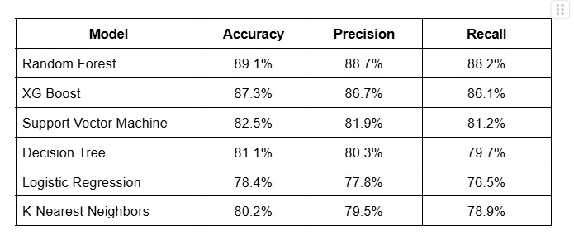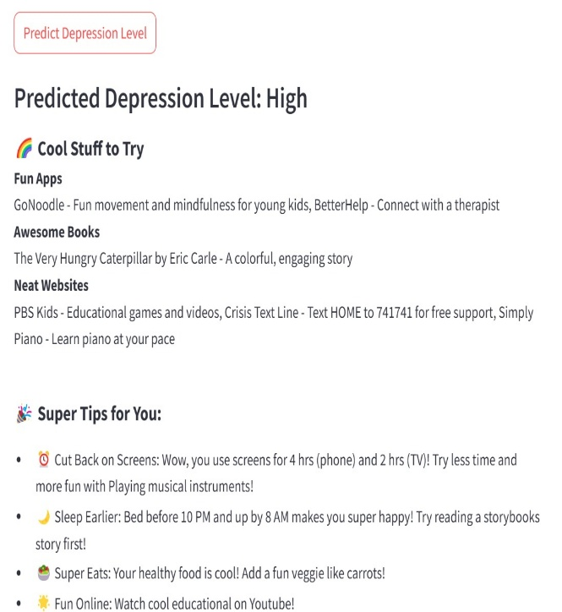

hhhhh

**Fig. 5 Depression level prediction & Tips Fig. 7 Comparison of Different Models**

# Conclusion:

# This study examines how children's use of social media affects their mental health by using machine learning techniques to examine psychological indicators, screen time, content consumption, and behavioral patterns. By successfully identifying important factors that contribute to mental health risks like anxiety, depression, and behavioral changes, the study makes it possible to use the Random Forest model for accurate classification [10]. A useful solution for real-time monitoring is also offered by the creation of an interactive Power BI dashboard and an Al-driven chatbot.

# In order to support children's digital well-being, this study emphasizes the significance of responsible social media use [8]. Additionally, a more thorough understanding of social media's impact on mental health is made possible by the combination of data-driven insights and interactive tools, enabling parents and educators to take preventative action. This study opens the door to early intervention techniques that can lessen the detrimental psychological effects of excessive social media use by identifying high-risk behavioral patterns and offering tailored advice. Ultimately, this study lays the groundwork for raising awareness, promoting a healthier digital ecosystem, and assisting kids and teenagers in engaging in social media in a balanced manner.

**References:**

[1] A.R. Primack, A.J. Shensa, H.Sidani, et al., 2017 “Social Media Use and and Perceived Social Isolation Among Young Adults in the U.S.” America Journal of Preventive Medicine, vol. 53

[2] T.J.R Naab, 2020, “The effects of social media on mental health: A systematic review,” Journal of Mental Health, vol. 29, no.5, pp. 543-550. doi: 10.1080

[3] K.E.M. Becker, 2019, “Understanding the impact of social media on mental health: A review,” Journal of Social Media in Society, vol.8, no.1, pp. 130-145 [Online]. Available: https://www.j-sms.org/8-1/

[4] P.A.H Cheng, C.T.N. Wong and S.M.Y. Lee, 2022, “The relationship between social media use and mental health outcomes in adolescents: A systematic review,” BMC Public Health, vol.22, no.1, pp.1-9. doi: 10.11

[5] D.D. Twenge, 2017, “Have Smartphones Destroyed a Generation?” The Atlantic, vol.320, no.3, pp.1-14. [Online]. Available: https://www.theatlantic.com/magazine/archive2017/09/has-smartphone-destroyed-a-generation/534198/.

[6] A.P.H Primack, D.H. Shensa and H. Sidani, 2021, “Social Media Use and Mental Health Outcomes: A Review of the Literature,” Current Opinion in Psychology, vol.39, pp. 67-71. doi:10.1016 /j.copsyc.2020.10.003

# [7] Vengalarao Pachava, Krishna Golla, 2024, “Machine Learning Analysis of Social Media’s Impact on mental health of Indian youth”, International Research Journal of Multidisciplinary Scope 5(2): 623-635

# [8] Biodoumoye George Bokolo, Qingzhong Liu, 2023, “Deep Learning-Based Depression Detection from Social Media: Comparative Evaluation of ML and Transformer Techniques”, 12(21): 4396 .

[9] Nurliyana Abas, Hanani Hussain, 2023, “Biodoumoye George Bokolo, Qingzhong Liu, 2023, “Exploring the interconnection of social media, mental health and youth: A bibliometric analysis”, Social and Management Research Journal 20(2) 2023, Research Journal 185 – 206.

[10] Veerpal Kaur, Aadrita Nandy, Jyoti Chaudhary, 2023, “Machine Learning for Early Detection of Child Depression: A Data Driven Approach”, IEEE 2nd International Conference.

[11] Betul Keles, Annmarie Grealish, 2023, “A systematic review: The influence of Social Media on depression, anxiety and psychological distress in adolescents”, International Journal of Adolescence and Youth, Volume 25

[12] Sriteja Kataru, Kathleen King, 2024, “Machine Learning Based Early Detection and Intervention for Mental Health Issues in Children”, IEEE 48th Annual Computers, Software and Application Conference.

[13] Deepali Joshi, Mansi Patwardhan, 2020, “An analysis of mental health of social media users using unsupervised approach”, Computers in Human Behaviour Reports, Volume 2.

[14] Vilas Sawrikar , Arshad Hussain, 2023, “A hybrid mental health prediction model using Support Vector Machine, Multilayer Perceptron, and Random Forest algorithms”, Healthcare Analytics, Volume 3.

[15] Konda Vaishnavi, U Nikhitha Kamath, 2021, “ Predicting Mental Health Illness using Machine Learning Algorithms”, Machine Learning Conference, Volume 12.

[16] Kaushik Chanda, Sandip Roy, 2022, “ Evaluating Mental Health Issues as Collected from Social Media by Machine Learning”, Department of Computational Science, Brainware University.

[17] Tarun Jain, Ashish Jain, Priyank Singh, 2021, “Machine Learning Techniques for Prediction of Mental Health”, 2021 Third International Conference on Inventive Research in Computing Applications (ICIRCA)

[18] Akshatha N K, Dr. Madhwaraj K G, 2024, Mental Health Prediction of Children Addicted to Digital Platforms, International Journal of Multidisciplinary Research, Volume 7.